
The minutes of the meeting of Satterthwaite Parish Council in the Parish Room, Satterthwaite on Monday 8th June 2026 at 7.30 pm.
Minutes
Item
Opening Administration
1 | Welcome and Introductions  Apologies  Emma Nield
2 | Declarations of interest  - To receive declarations by elected and co-opted members of disclosable pecuniary interests in respect of items on this agenda  None
3 | Requests for Dispensations  - The clerk to report any requests received since the previous meeting for dispensations to speak and/or vote on any matter where a member has a disclosable pecuniary interest.  None
4 | Minutes  - To authorise the Chair to review and sign last meetings minutes on 20th April 2026  Agreed as accurate record
Matters for consideration
5 | Public participation  - To receive comments and representations from members of the public in relation to any item on the agenda  None present
6 | Updates on ongoing issues and actions from last meeting  Review of action log  - Playground quotes – 3 companies contacted:  - Flights of Fantasy Teams 1st May  - Pentagon play face to face 7th May  - Playdale face to face 4th June  All quotes should be with us beginning July  - Zurich insurance – policy updated - action completed  - Village Parking progress - awaiting LDNPA response. Clerk to send a letter to the LDNPA to get response on outcome.  - Moor lane and motorcyclists - no update.  - Fibrus complaint meeting – nearly finished work so will stand down.  - Community Governance response – completed – awaiting result.  - AGAR return – to be approved/signed – see item 7  - Home to school transport consultation – response sent raising concerns – complete.
7 | Items for meeting not covered above  AGAR 25/26 – to approve/sign  - Pg 2 agreed  - Pg 3 agreed and signed  - Pg 4 awaiting internal auditor to complete once all paperwork checked  - Pg 5 agreed and signed  - Pg 6 agreed and signed. Highlighted issues with previous 24/25 AGAR being incorrect due to incorrect figures submitted on Pg 6. Compared to end of year accounts 24/25 and now rectified on this years 24/25 submission. 25/26 figures agreed to be accurate record. Statement will be produced for the website to explain change in figures between this and last year’s AGAR.  Exercise of public rights dates – agreed 15th June to 24th July
8 | Additional or urgent points to raise regarding Parish or Councillor matters  None
9 | Items for the Lengthsman  Nil to date
Planning
10 | Planning Consultations sought from Parish Council  - 7/2025/5659 - 1-5 Force Forge Cottages Septic tank upgrade – granted  - 7/2026/5171 - YMCA Training Centre – replacement of jetty – granted  - 7/2026/5047 - Installation of solar mounted solar system - granted
Finance
11 | Accounts since last meeting  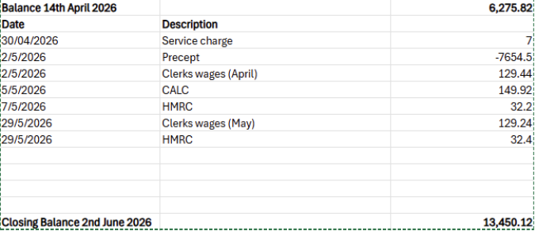  Agreed
12 | Review 26/27 year budget – revised – matching amounts from previous year  Agreed
  Outgoings 25/26 |  |  | Proposed budget 26/27
  Clerks wages | 1714.27 |  | Clerks wages | 1553.28
  HMRC | 411.6 |  | HMRC | 400
  Unity service charge | 72 |  | Unity service charge | 84
  Games night | 106 |  | Games night | 106
  Gritting | 500 |  | Gritting | 300
  Lengsthman | 1412 |  | Lengsthman | 1400
  Room hire | 57 |  | Room hire | 60
  CALC - fee | 145.58 |  | CALC - fee | 149.92
  CALC training | 100 |  | CALC training | 100
  Zurich | 194.25 |  | Zurich | 194.25
  Payroll | 144 |  | Payroll | 144
  Heartbeat Trust | 223.2 |  | Heartbeat Trust | 223.2
  Petty cash | 100 |  | Petty cash | 100
  Other (non-recurring maintenance etc) | 2647.92 |  | Other (non-recurring maintenance etc) | 1500
   | 7827.82 |  |  | 6314.65
   |  |  | Precept | 7654.5
   |  |  | Reserves | 1339.85
Key correspondence, consultations and reports not covered above
13 | Wings over Windermere Exemption Request Consultation – ends 25th June. No concerns.
14 | Parkamoor Workshop Rusland Reading Rooms - 8th June  Agreement in meeting that motorbikes shouldn’t be riding on this area, however this is a police issue and there is no resource to enforce it. Awaiting further outcome.
15 | Windermere Marathon 2026 – 14th June – Temporary Traffic Regulation Order
Council calendar
Closing administration
16 | Agenda items for next meeting  Sign off AGM minutes  Review of internal audit
17 | Next meeting date to be agreed  July 13th 7:30pm Satterthwaite Parish Room  7th September 7:30pm Parish Room

